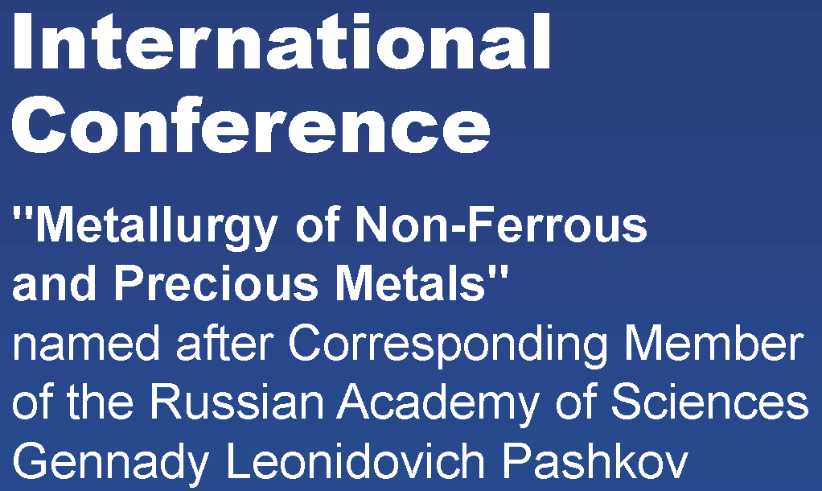
Dear Colleagues,
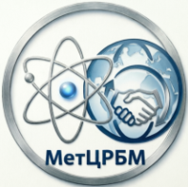
on behalf of Organizing Committee, we cordially invite you to participate in the 18th International Conference “Metallurgy of Non-Ferrous, Rare and Precious Metals” named after Corresponding Member of the Russian Academy of Sciences G.L. Pashkov.
Registration for the Conference, which will be held on September 21–25, 2026, at the Institute of Non-Ferrous Metals of Siberian Federal University (Krasnoyarsk), is ongoing.
We are currently receiving registration applications and are pleased to note that the program promises to be highly engaging and scientifically significant. We kindly ask all prospective participants to complete and submit their applications by the end of May, which will allow the Organizing Committee to prepare the Preliminary Program and publish it in advance on the official Conference website.
- Applications for participation may be submitted via e-mail to:
[conference_2026@bk.ru](mailto:conference_2026@bk.ru;
[nfmet@conference-2026.ru](mailto:nfmet@conference-2026.ru)
- Planned Conference Activities
The upcoming Conference program includes:
* Thematic sections:
* “Mining and Mineral Processing”
* “Non-Ferrous Metallurgy”
* “Precious Metals Metallurgy”
* “Rare Metals Metallurgy”
* Young Scientists School and Young Scientists Presentation Competition;
* Conference discussion platform and round-table discussions;
* Technical and cultural excursion program.
- September 21, 2026 (Monday)
Traditionally, the first day of the Conference will be dedicated to participant registration and the official opening ceremony.
Participants will be welcomed in the renovated foyer of the Institute of Non-Ferrous Metals by volunteers ready to provide any necessary information and assistance. A photo zone and exhibition dedicated to the scientific, industrial, and educational achievements of participating enterprises and organizations will also be organized there.
Organizations wishing to participate in the exhibition are requested to contact the Organizing Committee via the above-mentioned e-mail addresses to discuss organizational matters. Participation in the exhibition is free of charge.
On the same day (September 21, 2026), the Young Scientists School will begin its activities. The organizers and participants of the Conference place special emphasis on supporting research-oriented young professionals, including Master’s and Specialist degree students, postgraduate students, and early-career researchers. Each year, the Conference hosts a competition for presentations delivered by young scientists.
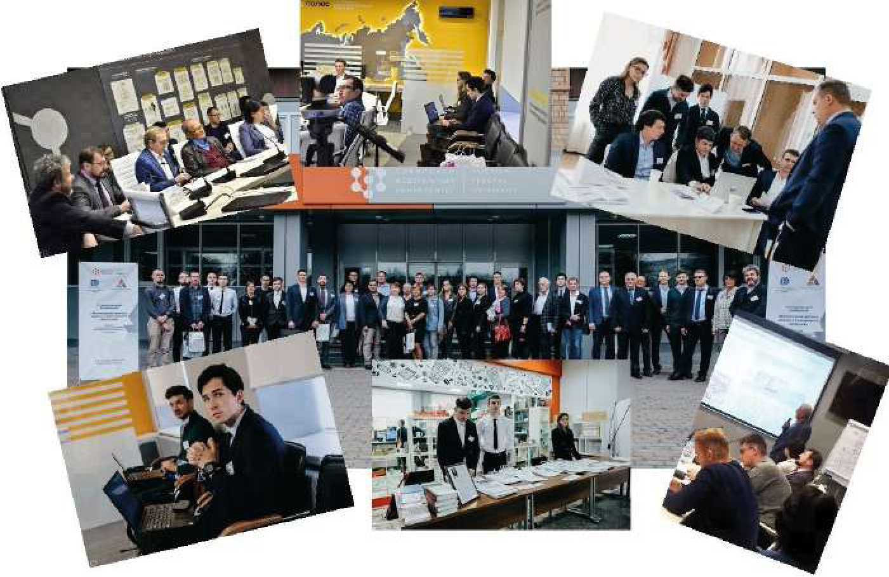
This year, the Young Scientists School will integrate chemistry, metallurgy, and digital technologies. Participants will attend lectures delivered by leading researchers, technological experts, and specialists in artificial intelligence. The School participants will also have the opportunity to work on real scientific and industrial case studies, take part in a hackathon, and join discussions on the future of chemistry and metallurgy in the context of the rapidly expanding implementation of artificial intelligence and digital technologies across industries.
- September 22–24, 2026 (Tuesday–Thursday)
The Conference will continue with thematic sessions in the areas of:
* Mining and Mineral Processing;
* Non-Ferrous Metallurgy;
* Precious Metals Metallurgy;
* Rare Metals Metallurgy.
Presentations will be delivered by representatives of industrial enterprises, research organizations, and higher education institutions.
During these days, round tables and discussion sessions will also be held to address current challenges in metallurgical production, the organization and implementation of scientific research, and the training of engineering and scientific personnel within the framework of ongoing higher education reforms.
Participants are welcome to propose discussion topics for the Conference discussion platforms. To do so, please contact the Organizing Committee.
- Excursion Program
The Conference excursion program includes visits to the Institute of Non-Ferrous Metals of Siberian Federal University and the Institute of Chemistry and Chemical Technology of the Siberian Branch of the Russian Academy of Sciences.
Within a few hours, participants will become acquainted with the rich history of both institutions, visit advanced laboratories, and learn about the scientific research and technological developments carried out by our researchers.
Excursions to metallurgical enterprises and landmark sites in the city of Krasnoyarsk will also be organized.
- September 25, 2026 (Friday)
Summarizing the Conference results and the official closing ceremony.
With best regards,
Organizing Committee

